Hashtable Table Application for Social Media Content Recommendation
Module 5 Critical Thinking Assignment

Andrew J. Cunningham
Colorado State University Global Campus
CSC506 – Design and Analysis of Algorithms
Dr. Brian Holbert
20 April 2025

Why Use a Hashtable?
Before we can examine the data structure we have to analyze a few key elements. What information do we have access to? Let’s assume that each value of the table is a node that contains the following properties:
- Unique User ID
- An object that contains the user’s information
- A list of strings that contains the user’s interests (algorithmically generated)
- And more, but I’ll leave it here for simplicity

Next, what assumptions can we make about how this table is going to get used:
- User profiles get created once
- User profiles almost never get deleted or moved
- The unique ID never changes
- Updates and gets are made a LOT, meaning that lookup time has be essentially instant.

Benefits of the Hashtable:
- A unique user ID provides a convenient key.
- If user IDs are created at random then the number of keys per bucket will be statistically consistent. This prevents the worst case access time of O(n) (Garcia, 2024).
- A hashtable with few collisions has O(1) get time.
- Given the distribution, chaining makes sense here as it avoids the worst case of all nodes ending up in the same bucket. Linear probing would make it messy and require a very large array. Chaining can allow the array to scale as needed.

Implementation:
Interestingly, I’ve spent a fair portion of today exploring intricacies of the hashtable after finding details in the text book. The discussion on “flagging” during linear-probing caught my eye, and I was curious to implement it. Also, I know that hashtables are dictionaries, but I was curious to know if we could make a hash-table without the key. So I made one that creates its own key out of a hash of the value. Here’s the code if you want to see it:
https://gitlab.com/shadnezzarcham/doodling/-/blob/main/hashtable_andy.py?ref_type=heads
For this hash table I use a traditional <Key, Value> dictionary that is implemented by a table of linked lists (UATeam, 2024). The code is shared down below and included a separate file.

Challenges:
- Using python’s hash() function. This helps make sure that the keys are unique, even though I assume that the userID is relatively distributed. It also helps make the algorithm more robust incase a non-int key is given.
- Practicing manipulating linked list. It’s always great practice removing elements form a linked list, as we have to carefully select where we’re looking.
- In the put() method I increment the table size, but I also used size to hash the key, resulting in the index always being one as soon as the array was full. Now I just hash to the length of the array.

Code:
# hashtable_andrew.py

# Andrew Cunningham
# 20 Apr 2025

'''
Implements a chaining hashtable
'''

class hash_table_andrew:
def __init__(self, size):
self.hashTable = [None] * size
self.size = 0

class __Node:
'''private inner class to use as nodes for the hashtable buckets'''
def __init__(self, key, value, next = None):
self.key = key
self.value = value
self.next = next

def __hash(self, key):
'''uses python hash to create a unique hash'''
return hash(key) % len(self.hashTable)

def put(self, key, value):
'''adds value to the hashtable using the key to hash with'''
index = self.__hash(key)
new_node = self.__Node(key, value, None)

# The spot is empty
if self.hashTable[index] == None:
self.hashTable[index] = new_node
return

# the spot contains a node, let's find the end of that linked list
curr_node = self.hashTable[index]
while curr_node.next != None:
curr_node = curr_node.next

# found the end, append the node
curr_node.next = new_node

self.size += 1

return

def get(self, key):
'''Returns the value associated with Key, None if key not found'''
index = self.__hash(key)
curr_node = self.hashTable[index]

if curr_node == None:
# The bucket was empty
return None

while (curr_node.key != key):
# the payload wasn't key
curr_node = curr_node.next
if curr_node == None:
# hit the end of the linked list
return None

# the curr_node currently is the target
return curr_node.value

def remove(self, key):
'''removes, and returns, the value associated with key. None if not found'''
index = self.__hash(key)

if self.hashTable[index] == None:
# There was no node at that spot
return None

curr_node = self.hashTable[index]

if curr_node.key == key:
# the <key, value> is the head
self.hashTable[index] = curr_node.next
self.size -= 1
return curr_node.value

while curr_node.next != None:
if curr_node.next.key == key:
# the <key, value> is next, save the value and skip over it in
# the linked list
value = curr_node.next.value
curr_node.next = curr_node.next.next
self.size -= 1
return value

# we have hit the end of the linked list in the bucket
return None

def print_hashtable(self):
'''Prints the table'''
for i, node in enumerate(self.hashTable):
print(f"[{i}]:", end=" ")
if node is None:
print("None")
else:
chain = []
while node is not None:
chain.append(f"({node.key}: {node.value})")
node = node.next
print(" -> ".join(chain))

# hashtable_test.py

# Andrew Cunningham
# 20 April 2025

'''
Tests hash_table.py
'''

from hashtable_andrew import hash_table_andrew

class Payload:
'''Defines a payload for the user's data that can be put into the hashtable'''
def __init__(self, userID, userInfo = None, userInterests = None):
self.userID = userID
self.userInfo = userInfo
self.userInterests = userInterests

def __str__(self):
return f"<{self.userID}, {self.userInfo}>"

user_list = {
1: Payload(1, "A", None),
2: Payload(2, "B" ,None),
3: Payload(3, "C" ,None),
4: Payload(4, "D" ,None),
5: Payload(5, "E" ,None),
6: Payload(6, "F" ,None),
7: Payload(7, "G" ,None),
8: Payload(8, "H" ,None)
}

table = hash_table_andrew(6)

print("Test 1: Add all of the elements, there will be 2 collisions")
for key, value in user_list.items():
table.put(key, value)

table.print_hashtable()

print("/n Test 2: find a few elements")
print(table.get(2))
print(table.get(6))

print("\nTest 3: remove an element that's chained and not chained")
table.remove(3)
table.remove(8)
table.print_hashtable()

print("\nTest 4: get an element that's not there")
print(table.get(3))

print("\nTest 5: add three elements to 3")
table.put(3, Payload(3, "X", None))
table.put(9, Payload(9, "Y", None))
table.put(15, Payload(15, "Z", None))
table.print_hashtable()

print("\nTest 6: remove the middle element of 3")
table.remove(9)
table.print_hashtable()

Output
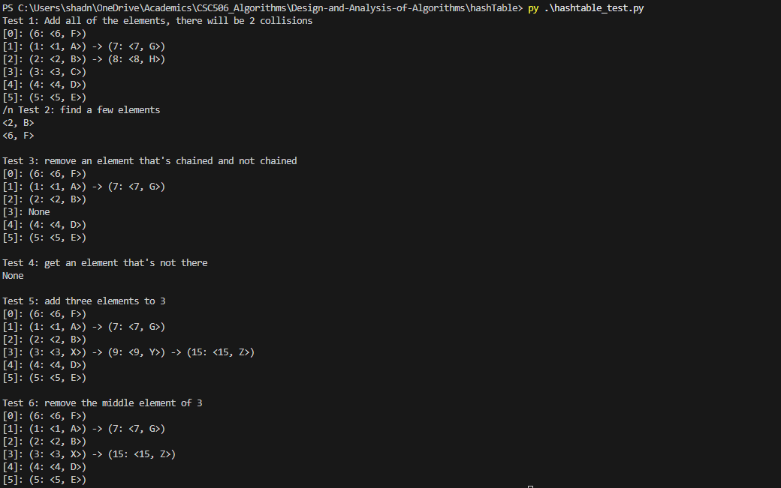

References:
Garcia, F. (2024, March 18). Understanding hash tables. Baeldung on Computer Science. https://www.baeldung.com/cs/hash-tables
UATeam. (2024, November 24). Implementing a hash table in Python: A step-by-step guide. Medium. https://medium.com/@aleksej.gudkov/implementing-a-hash-table-in-python-a-step-by-step-guide-a7ef0f231d3c

